**EXPLAINATION OF THE ASSIGMENT – DONE BY TEJAS V KANGOD**

Greetings! Below I will share snapshots of the webpages and explain it briefly to help you navigate the assignment easily. Also I have put snap which shows code runs successfully

**SNAPSHOTS**

**1)**

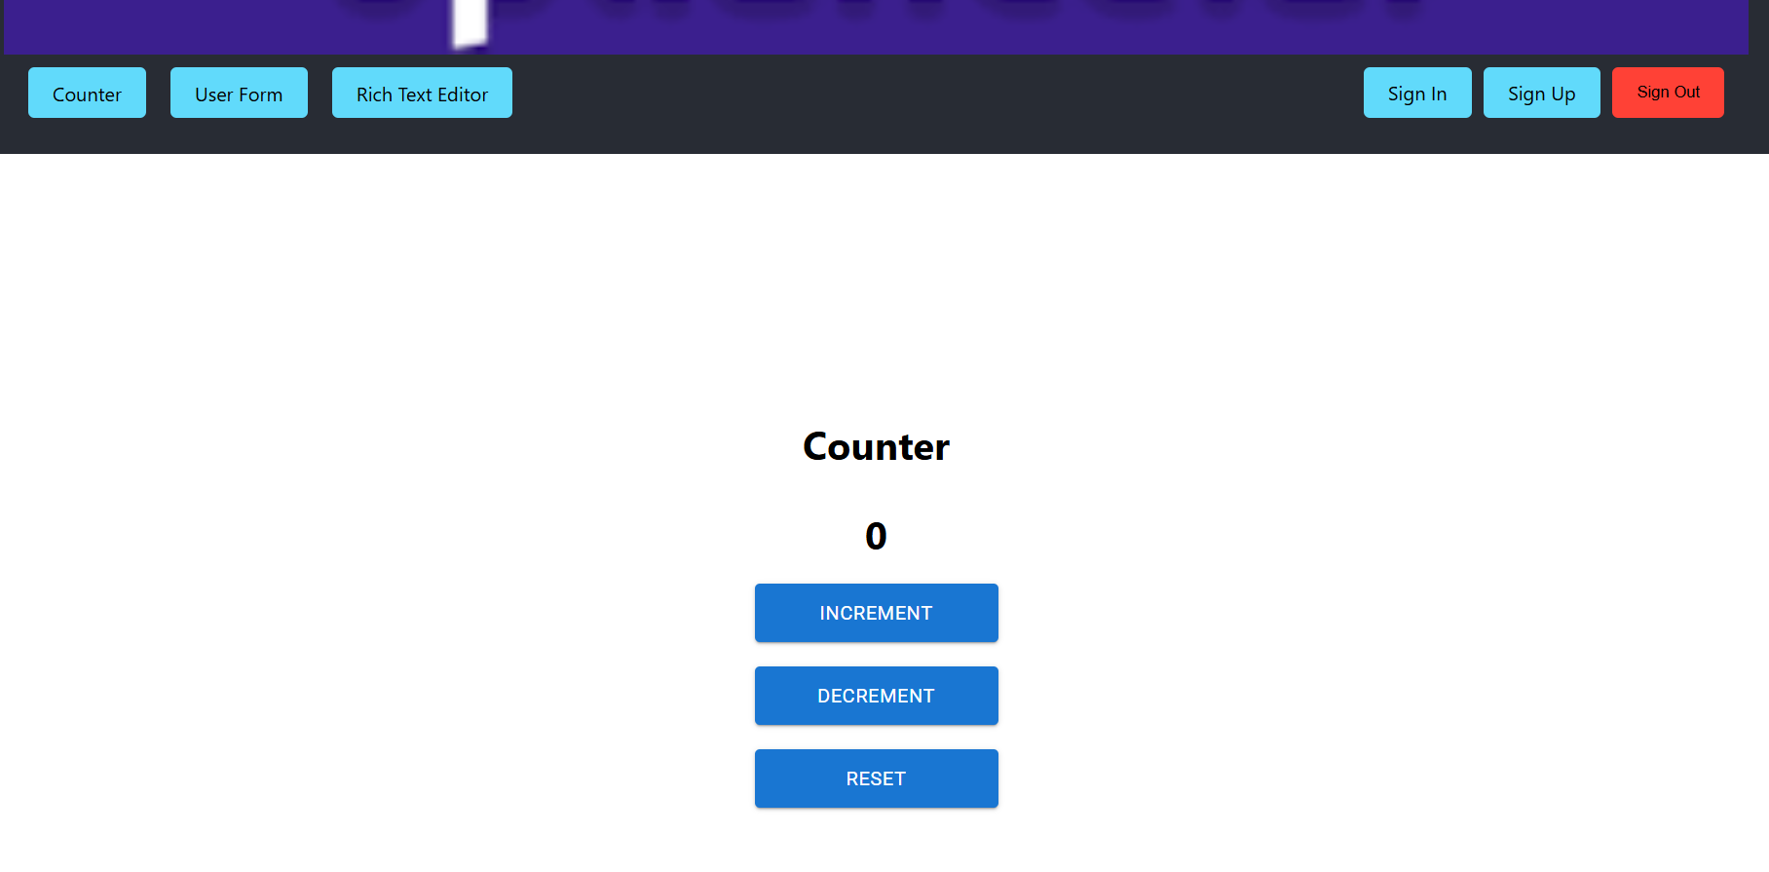

2)

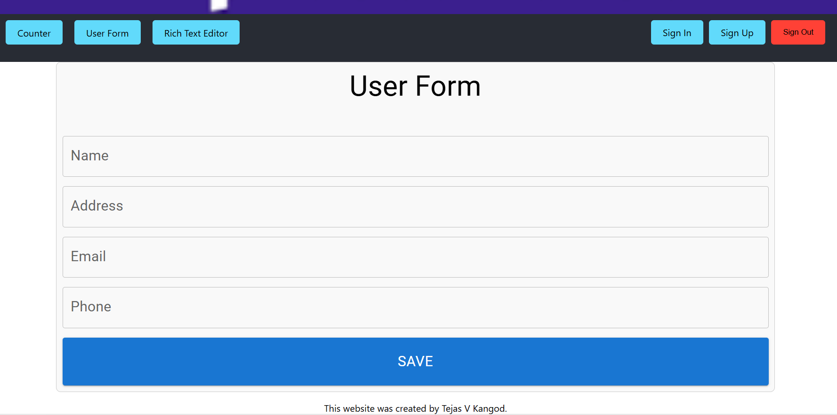

3)

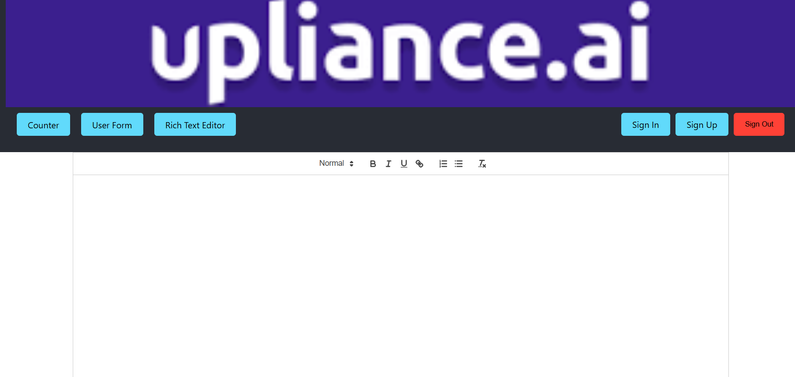

4)

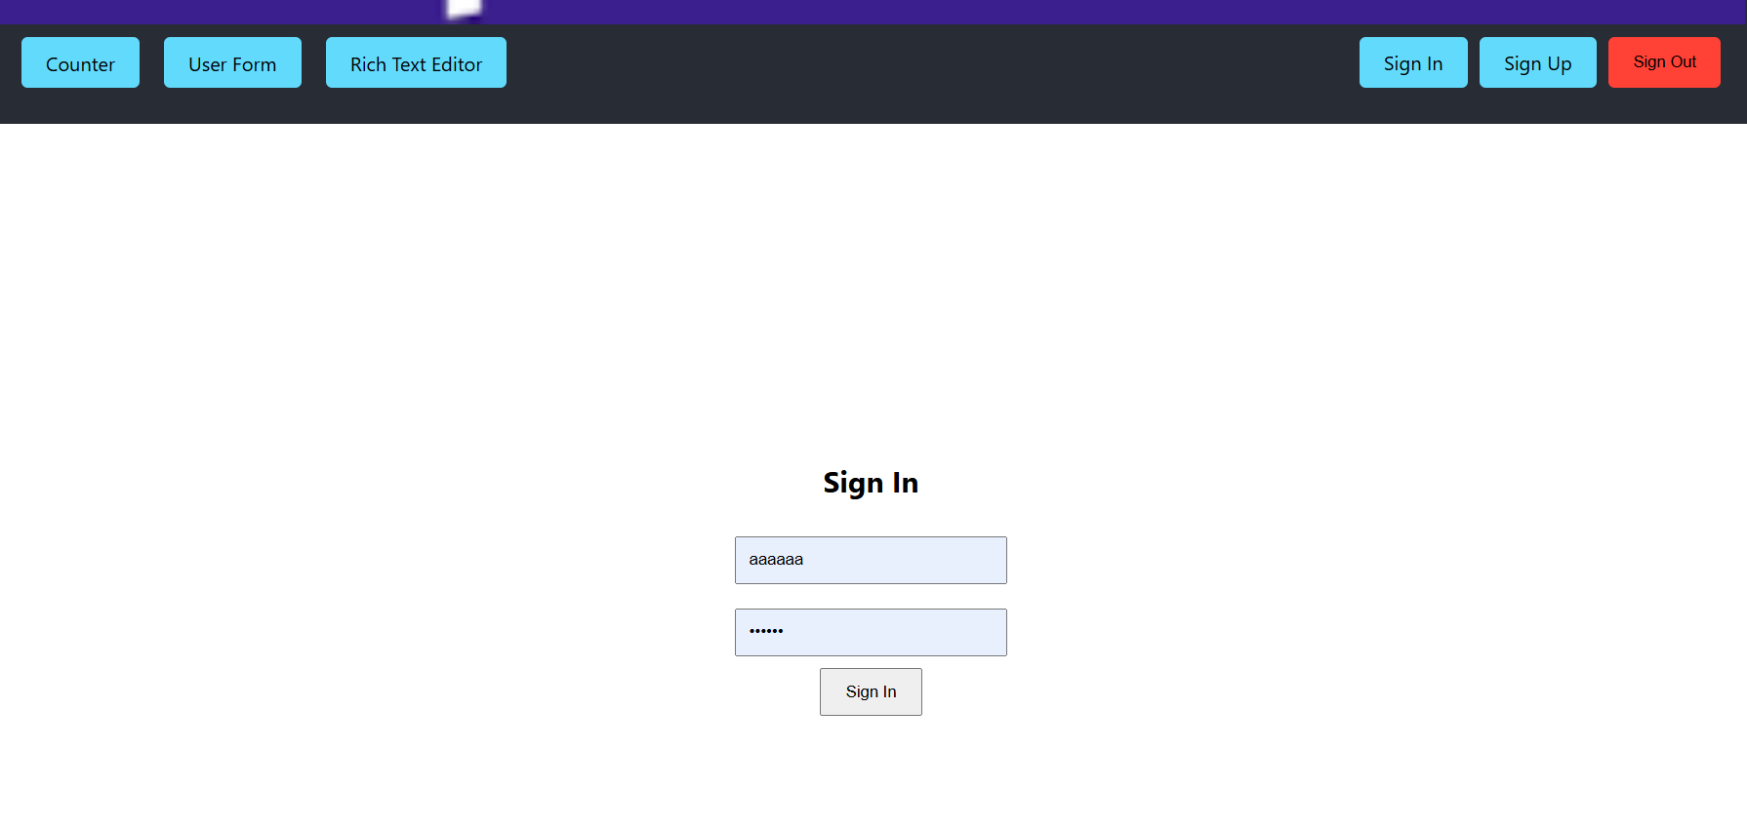

5)

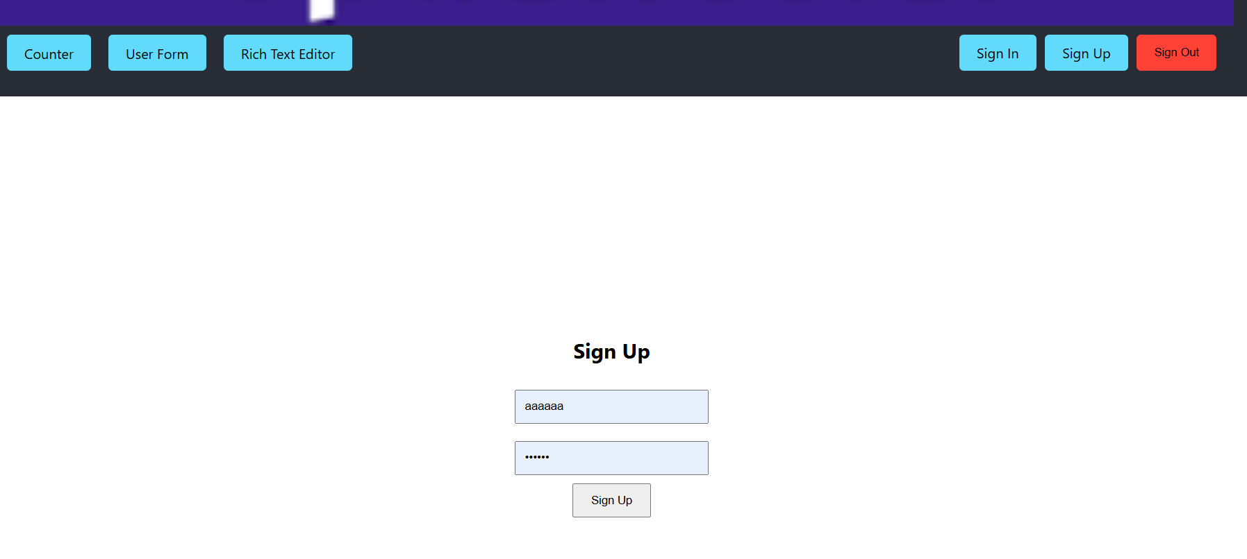

6)

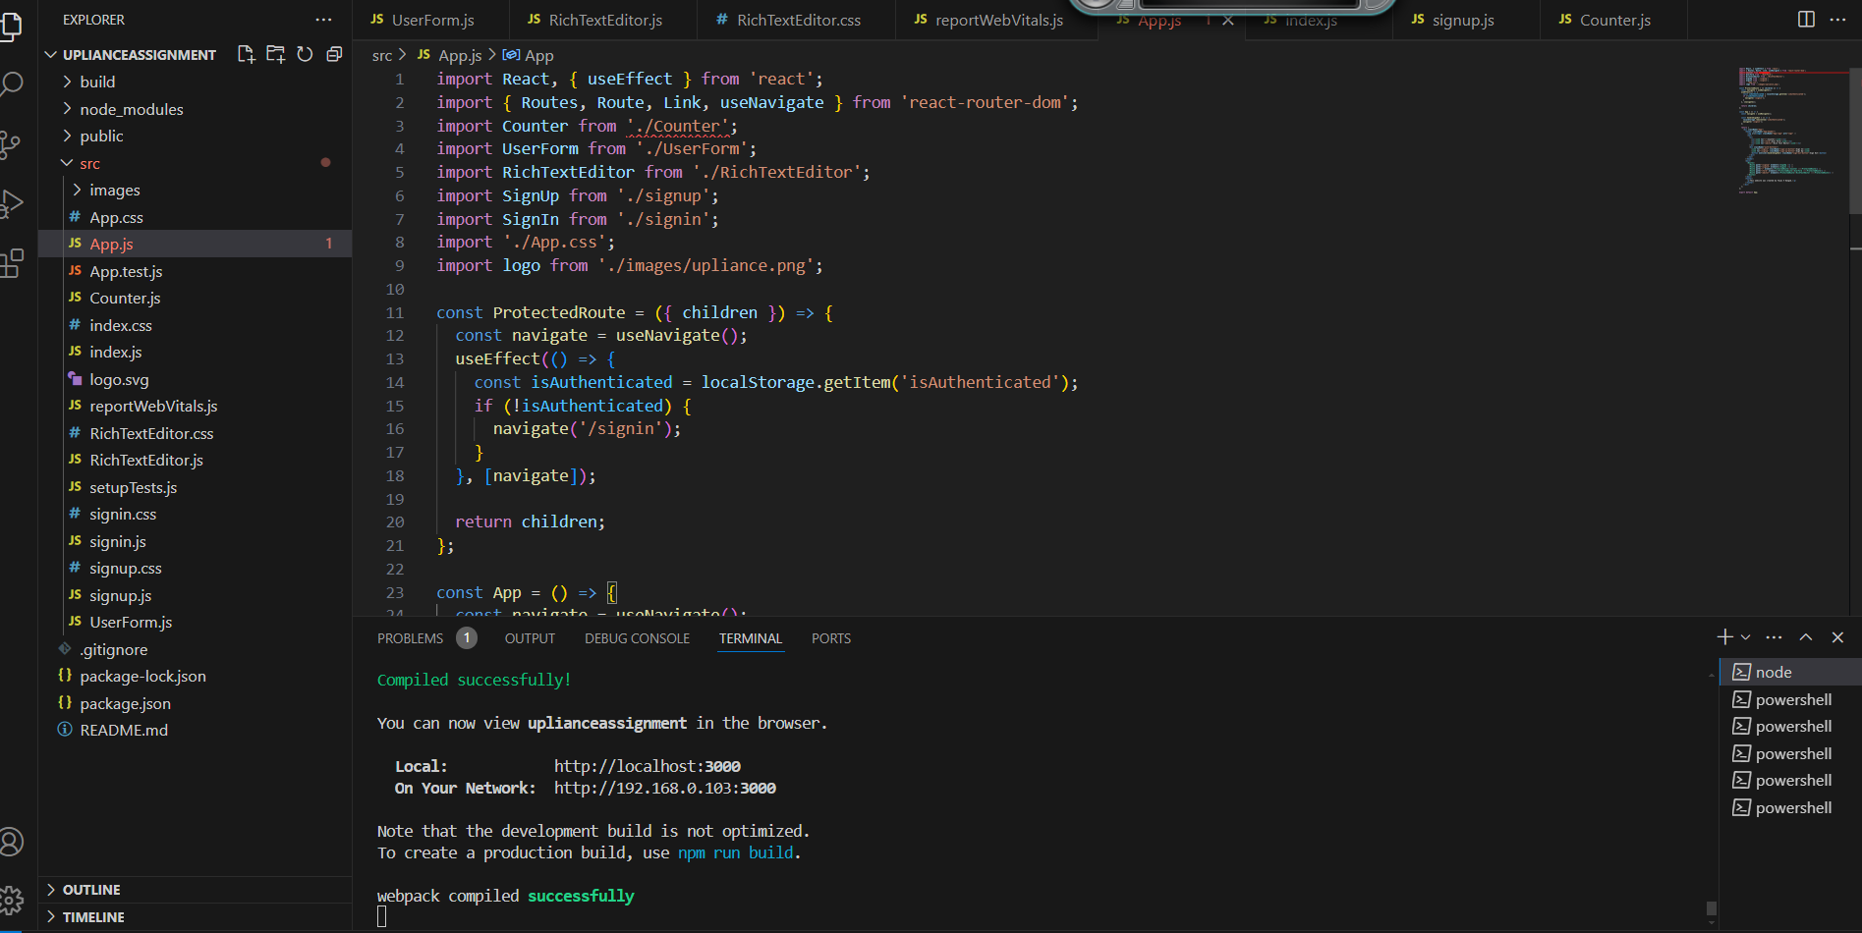

**EXPLAINATION**

1. The first image shows the screen when counter is pressed. Increment, decrement and reset works as required.
2. The second image shows the User Form. The result is saved In local storage and if the user tries to exit without saving a pop up is shown.
3. Third image shows text editor developed as mentioned
4. For additional features- I was able to implement sign up, sign in and sign out within the time provided.
   1. Sign up: the user must give username and password. These are stored in the local storage
   2. Sign In- when user tries to sign in, the username and password are matched with ones in local storage. If the match then access granted else pop up shows.
   3. Sign out- takes user to sign in page- logs out
   4. The user cannot use the counter, user form, text editor without signing in